**What is A/B Testing?**

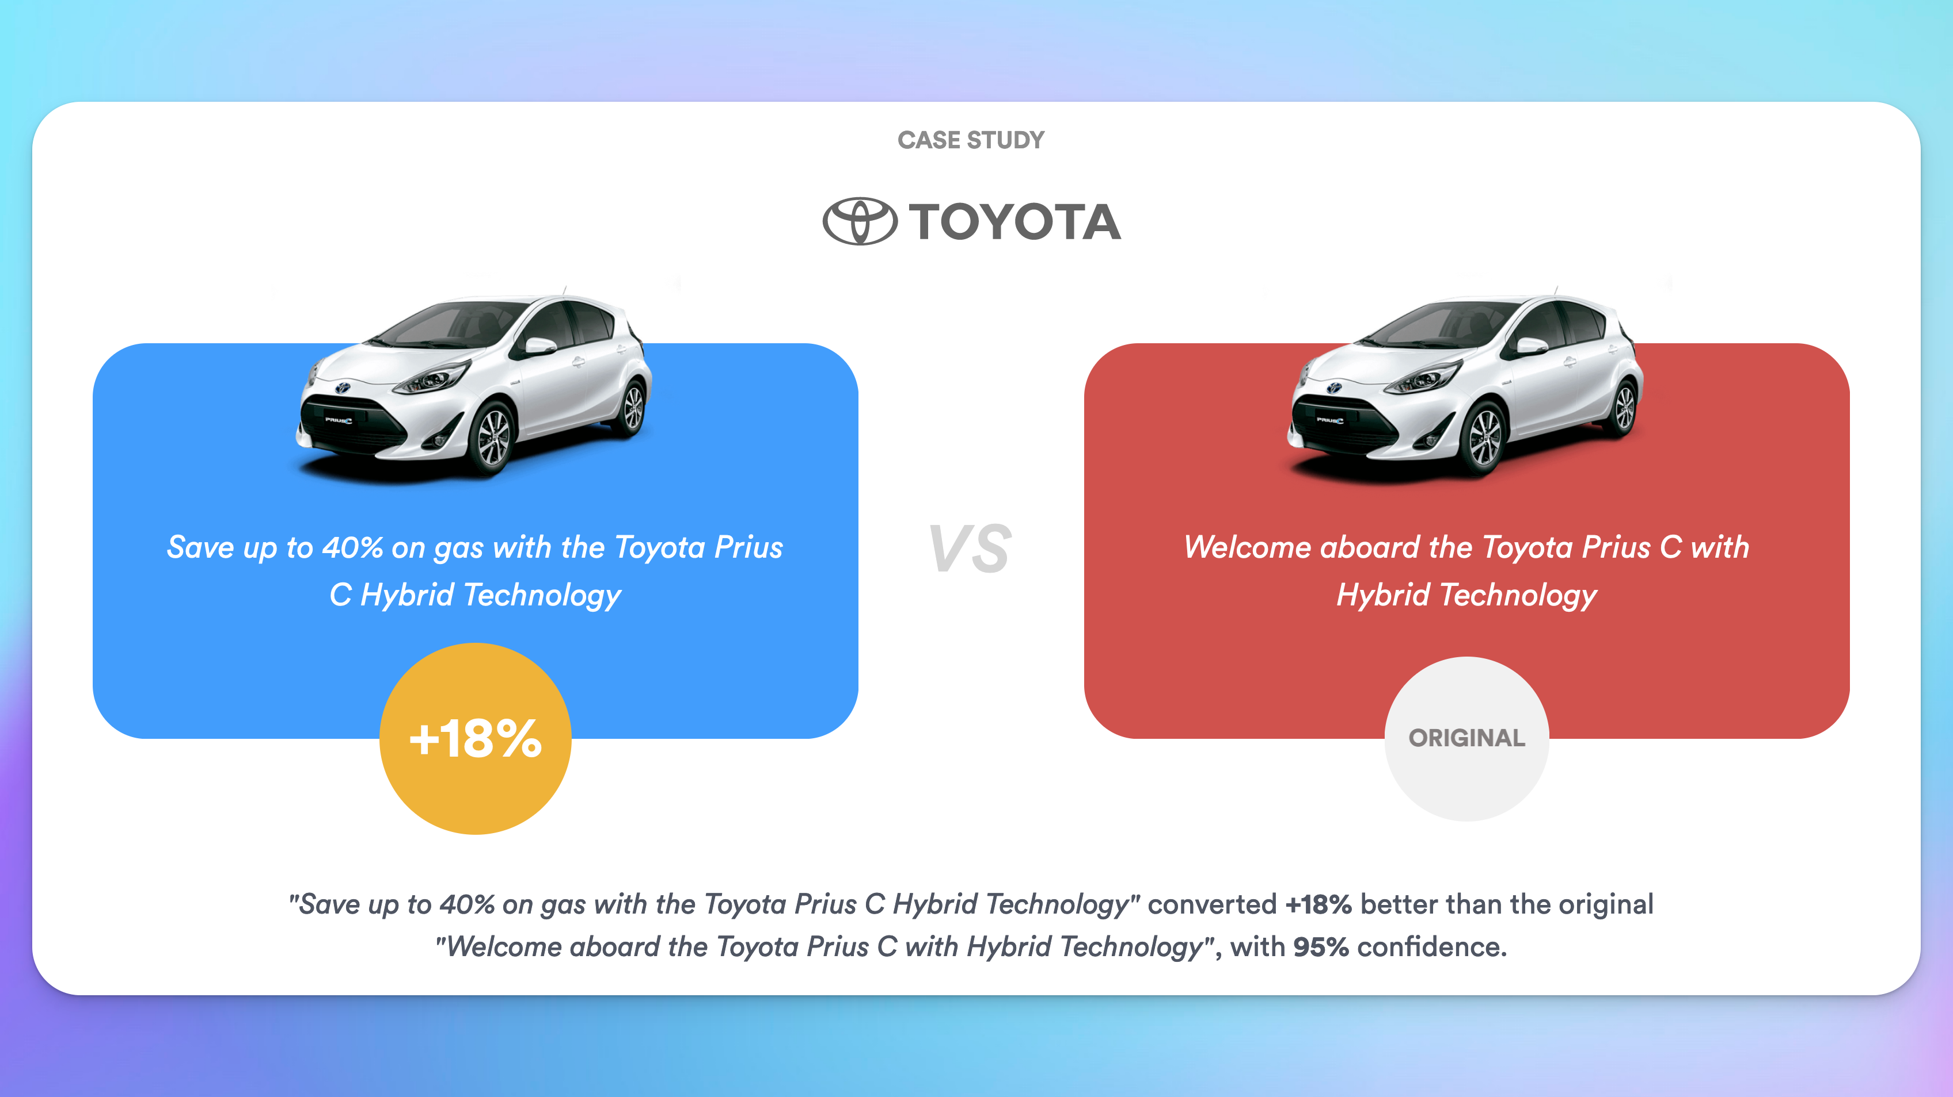

A/B testing, also known as split testing or bucket testing, is a method of comparing two versions of a webpage or other user experience to determine which one performs better. It's essentially an experiment where two or more variants of a page are shown to users at random, and statistical analysis is used to determine which variation performs better for a given conversion goal.

Here's a basic example of how it works:

1. **Define a Goal:** The first step in A/B testing is to identify a goal. This could be anything from increasing click-through rates, improving conversion rates, reducing bounce rates, or any other metric that's important for the success of your website or app.

2. **Create Variants:** Next, you create two different versions of your webpage. Version A is usually the current design (known as the control), while Version B is the new design.

3. **Split Your Audience:** You then split your audience into two groups. One group sees Version A of your webpage, and the other group sees Version B.

4. **Collect and Analyze Data:** As users interact with either Version A or B, their interaction is measured and collected into an analytics dashboard and analyzed through a statistical engine.

5. **Implement the Winner:** You determine which version was more successful at achieving your designated goal, and then implement that version for all users.

A/B testing is a powerful way to improve your website or app based on actual user behavior, rather than assumptions. It can help to improve a variety of metrics and ultimately lead to a better user experience.